**Unleashing the Potential of Our Youth: A Student Performance Analysis**

**DATA ANALYTICS REPORT**

***Submitted by :***

**Disha Chauhan - 20BCE10087**

**Navdha Kadian - 20BCE10336**

**Ayush Jerath - 20BCE10987**

**Avirash Badgainyan - 20BCG10041**

** &** 

**Smart Internz VIT Bhopal University**

**Data Analytics Bhopal**

**Madhya Pradesh**

**June 2023**

***1. INTRODUCTION***

**1.1 Overview**

The kids of today are our society's future, and their potential is a priceless asset that must be developed and made available. Every young person has special talents, skills, and goals that, if encouraged and cultivated, can advance their own development and have a profound effect on the world. Understanding the elements that go into realising their potential and fostering an environment that supports their achievement is crucial.

The project in the field of data analytics on the topic of "Unleashing the Potential of Our Youth: A Student Performance Analysis" aims to leverage data analytics techniques to gain insights into student performance and unleash the full potential of young learners. By analysing comprehensive data sets and applying various data analysis techniques, the project seeks to understand the factors influencing student success, develop targeted interventions, and inform evidence-based policies to enhance educational outcomes.

The project begins by collecting and integrating data from multiple sources, including academic records, standardised test scores, attendance records, participation in extracurricular activities, and socio-economic indicators. Ensuring data privacy and security is a fundamental aspect of the data collection process.

The collected data is then subjected to various data analysis techniques, including descriptive analytics, predictive analytics, correlation analysis, and data visualisation. These techniques enable the identification of patterns, correlations, and trends in student performance data.

The insights gained from the data analysis are applied in several ways. Firstly, personalised learning approaches can be implemented by tailoring instruction and learning materials to meet the unique needs of individual students. This enhances student engagement and boosts academic performance.

Secondly, targeted interventions are developed based on predictive analytics to identify at-risk students early on. Teachers, counsellors, and parents collaborate to provide additional support, such as tutoring, mentoring, or counselling, to help struggling students improve their performance.

Additionally, resource allocation decisions can be informed by the analysis to ensure that funding, personnel, and resources are allocated where they are most needed. This helps address disparities and create equitable learning environments.

Moreover, the insights gained from the analysis can inform evidence-based policies. Policymakers can formulate initiatives to reduce educational inequalities, enhance access to quality education, and establish comprehensive support systems based on the identified factors influencing student performance.

Throughout the project, challenges such as data fragmentation, privacy concerns, limited data availability, lack of standardised metrics, interpretation biases, and implementation obstacles are addressed to ensure the accuracy and effectiveness of the data analytics process.

Ultimately, the project aims to foster a data-driven education system that empowers students and provides them with the necessary support to reach their full potential. By leveraging data analytics, the project endeavours to create a supportive and inclusive environment that maximises the academic growth and success of our youth.

## 

## **1.2 Purpose**

To fully understand the aspects that contribute to our youth's success and growth, completing a student performance analysis is necessary in the context of maximising their potential. The analysis tries to achieve the following goals by looking at several facets of student performance, such as academic success, extracurricular activities, and personal development:

* **Identify Factors Influencing Student Performance:** By analysing comprehensive data sets, the project seeks to uncover the various factors that contribute to student success or hinder their progress. This includes examining academic records, extracurricular activities, socio-economic backgrounds, and other relevant information. Understanding these factors can help educators, policymakers, and parents make informed decisions to support students effectively.
* **Addressing Barriers:** The analysis tries to remove the obstacles limiting student performance and potential. The research aims to provide solutions and treatments to solve these hurdles by finding common roadblocks such socioeconomic inequality, resource availability, and learning difficulties.
* **Improve Academic Interventions:** Through data analytics, the project aims to identify early warning signs and indicators of academic challenges. By predicting and recognizing patterns of underperformance, educators can intervene proactively and provide targeted support to struggling students. This includes personalised learning plans, tutoring, mentoring, or counselling, tailored to meet individual student needs.
* **Enhance Resource Allocation:** Data analytics can assist in identifying resource gaps and disparities in educational institutions. By analysing student performance data alongside resource allocation, policymakers can make informed decisions about where resources should be directed to address inequities. This includes allocating funding, personnel, infrastructure, and educational materials where they are most needed.
* **Foster a Data-Driven Education System:** The project intends to promote the integration of data analytics in the education system. By showcasing the value and benefits of data-driven decision-making, the project aims to encourage educational institutions to adopt data analytics practices, standardise data collection methods, and establish protocols for data privacy and security.

Overall, the purpose of the project is to leverage data analytics to unleash the potential of our youth by gaining insights into student performance, facilitating targeted interventions, improving resource allocation, informing evidence-based policies, and fostering a data-driven education system. By utilising data effectively, the project aims to enhance educational outcomes and create a supportive environment that empowers students to reach their full potential.

***2 LITERATURE SURVEY***

**2.1 Existing problem**

While data analytics has the potential to greatly impact student performance analysis and help unleash the potential of our youth, there are several challenges and limitations that need to be addressed:

* **Data Fragmentation and Incompatibility:** Educational data is often fragmented across various systems, making it difficult to integrate and analyse effectively. Inconsistent data formats and lack of interoperability between different platforms hinder comprehensive analysis and limit the insights that can be derived.
* **Data Privacy and Security:** Student data contains sensitive information that must be handled with utmost care. Maintaining data privacy and security is a significant concern in student performance analysis. Strict protocols and measures need to be in place to ensure compliance with data protection regulations and safeguard students' personal information.
* **Limited Data Availability:** While educational institutions collect various data points related to student performance, not all relevant data is readily available or easily accessible for analysis. Incomplete or inconsistent data sets can lead to biassed or inaccurate insights, limiting the effectiveness of data analytics in identifying the factors influencing student success.
* **Lack of Standardised Metrics:** There is a lack of standardised metrics for measuring student performance across different educational systems and institutions. This makes it challenging to compare and analyse student outcomes accurately. The absence of consistent metrics hampers the ability to draw meaningful conclusions and develop actionable interventions.
* **Interpretation and Contextual Understanding:** Data analytics provides valuable insights, but it is crucial to interpret and understand the data within the appropriate context. The analysis should consider the socio-economic backgrounds, cultural factors, and individual circumstances of students to avoid oversimplification or misinterpretation of the results.
* **Equity and Bias:** Data analytics should be mindful of potential biases and inequities in student performance analysis. Biases may arise from factors such as socio-economic disparities, cultural differences, or systemic inequalities within the education system. It is essential to mitigate these biases and ensure equitable outcomes for all students.

Addressing these existing problems requires collaboration among educational institutions, policymakers, data analysts, and other stakeholders. Efforts should focus on standardising data collection, ensuring data privacy, promoting data sharing agreements, developing contextually relevant metrics, and implementing interventions that address the specific needs and challenges of diverse student populations. By overcoming these challenges, data analytics can truly unleash the potential of our youth and improve student outcomes.

**2.2 Proposed solution**

The proposed solution aims to leverage data analytics to analyse student performance and unleash the potential of our youth. By utilising comprehensive data sets, including academic records, extracurricular activities, and socio-economic backgrounds, we can gain valuable insights into the factors influencing student success. This analysis will enable educators, policymakers, and parents to make informed decisions and implement targeted interventions to support students' academic growth and development.

**Solution :-**

1. **Data Collection and Integration:** To conduct a comprehensive student performance analysis, we need to collect and integrate data from multiple sources. These sources include academic records, standardised test scores, attendance records, participation in extracurricular activities, socio-economic indicators, and any other relevant information. Ensuring data privacy and security is of paramount importance throughout the data collection and integration process.
2. **Data Analysis Techniques:** The data collected will be subjected to various data analysis techniques to uncover patterns, correlations, and trends. Some potential analysis techniques include:
   1. **Descriptive Analytics:** This technique will help provide a summary of student performance metrics, such as average grades, attendance rates, and participation in extracurricular activities. Descriptive analytics will enable us to understand the current state of student performance.
   2. **Predictive Analytics:** By utilising predictive modelling techniques, we can forecast future student performance based on historical data. This will allow us to identify early warning signs and proactively intervene to prevent academic challenges.
   3. **Correlation Analysis:** By examining the relationship between various factors, such as socio-economic background and academic achievement, we can identify key drivers of student performance. This analysis will help policymakers and educators tailor interventions to address specific needs.
   4. **Data Visualization:** Presenting the analysed data through interactive and visually appealing dashboards will facilitate better comprehension and decision-making. Visual representations can help identify trends, outliers, and areas requiring immediate attention.

***3. THEORETICAL ANALYSIS***

**3.1 Block diagram**

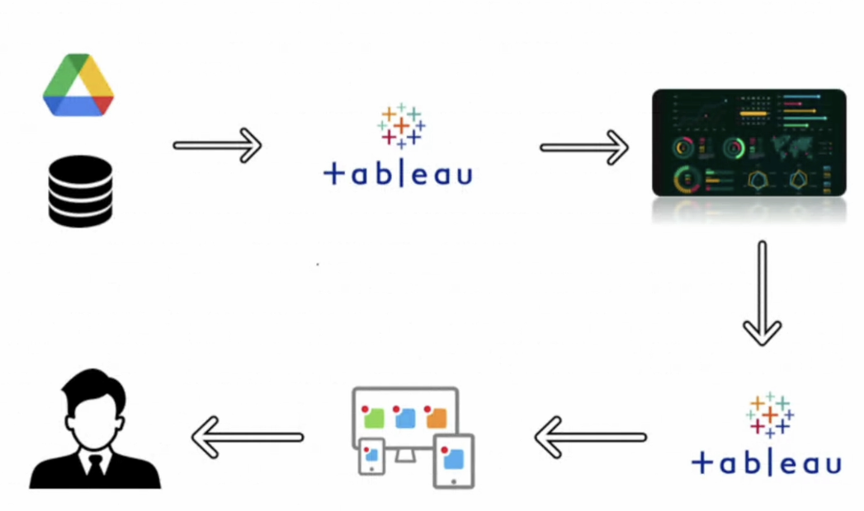

**Technical Architecture**

**3.2 Hardware / Software designing**

Hardware requirements of the project:

* **Computer System:** A reliable computer system with sufficient processing power and memory capacity to handle large datasets and perform complex data analytics tasks efficiently.
* **Storage:** Adequate storage space to store and manage the collected data, as well as any intermediate or processed datasets generated during the analysis.

Software requirements of the project:

* Database management systems i.e. **MySQL** for data collection, data cleaning, and data integration to consolidate the diverse data sources into a unified dataset. (Data Collection and Integration)
* **Tableau** for performing data analytics tasks, including descriptive analytics, predictive modelling, correlation analysis, and data visualisation. (Data Analytics and Visualization)
* Document sharing platforms like **Google Docs** to facilitate teamwork, documentation of the project.
* GitHub for uploading the project/Git repositories.

***4. EXPERIMENTAL INVESTIGATIONS***

### **4.1 Project Flow**

### To accomplish this, we have to complete all the activities listed below,

* Define Problem / Problem Understanding
  + Specify the business problem
  + Business requirements
  + Literature Survey
  + Social or Business Impact.
* Data Collection & Extraction from Database
  + Collect the dataset,
  + Storing Data in DB2
  + Perform SQL Operations
  + Connect DB2 with Cognos
* Data Visualisations
  + No of Unique Visualisations
* Dashboard
  + Responsive and Design of Dashboard
* Story
  + No of Scenes of Story
* Performance Testing
  + No of Calculated field
  + No of Visualization/Graphs
* Web Integration
  + Dashboard, Report and Story embed with UI With Flask
* Project Demonstration & Documentation
  + Record explanation Video for project end to end solution
  + Project Documentation-Step by step project development procedure

**MILESTONE 1: Define Problem / Problem Understanding**

**Activity 1: Specify the business problem**

A country's growth is strongly measured by the quality of its education system. Education sector, across the globe has witnessed sea change in its functioning. Today it is recognized as an industry and like any other industry it is facing challenges, the major challenges of higher education being decrease in students' success rate and their leaving a course without completion.

Analysing student work is an essential part of teaching. Teachers assign, collect and examine student work all the time to assess student learning and to revise and improve teaching. Ongoing assessment of student learning allows teachers to engage in continuous quality improvement of their courses. Many factors can influence a student's performance, including the influence of the parents' educational background, test preparation and so on.

The dataset contains the marks secured by 1000 students from a school. This project analyses and correlates student performance with different attributes. The analysis aims to understand the influence of important factors such as parental level of education, the status of test preparation courses etc. on the performance of the students in the exams.

**Activity 2: Business requirements**

Business requirement of student performance analysis refers to the need of educational institutions or organisations to gather, analyse, and use data on students' academic performance to improve teaching and learning outcomes. This process involves collecting, analysing, and interpreting data on various aspects of student performance such as test scores, attendance, behavioural patterns, and demographic information. The business requirement of student performance analysis is crucial for educational institutions to provide high-quality teaching and learning outcomes and improve student success. The ultimate goal is to gain insights and improve performance through data visualisation techniques.

**Activity 3: Literature Survey**

A literature survey for Student Performance Analysis involves reviewing academic articles, and other sources related to the analytics of Students Performance. Researchers and practitioners in the field are exploring new methods and tools to improve teaching and learning outcomes and provide more personalised learning experiences for individual students. The analysis can provide a comprehensive understanding of the significance, challenges, and opportunities associated with Student Performance.

**Activity 4: Social or Business Impact**

**Social Impact:** It has a positive social impact by improving student outcomes, promoting equity in education, and increasing transparency and accountability in the education system.

**Business Model/Impact:** It has a significant impact on businesses and educational institutions, as it provides valuable insights into student learning and helps improve teaching, increasing efficiency, and promoting competitiveness.

**Milestone 2: Data Collection & Extraction from Database**

Data collection is the process of gathering and measuring information on variables of interest, in an established systematic fashion that enables one to answer stated research questions, test hypotheses, and evaluate outcomes and generate insights from the data.

**Activity 1: Collect the dataset**

Data contains all the meta information regarding the columns described in the CSV files. The name of the file is StudentPerformance.csv.

**Description for StudentPerformance.csv**: The file StudentPerformance.csv contains 1000 rows. Each row corresponds to an individual student with details and marks in respective subjects. The columns are:

Categorical columns are:

* Gender: Male or Female
* Race/ethnicity: 5 groups, from group A to group E
* Parental level of education: from high school to a master’s degree
* lunch: free/reduced or standard.

Numerical Columns are:

* Maths score: out of 100
* Reading score: out of 100
* Writing score: out of 100

**Please use the link to download the dataset:**

Link: [StudentPerformance.csv](https://drive.google.com/file/d/1XSUCisqBPtXWnoOLaHZzdaMe2RIjpmjq/view?usp=sharing)

**Activity 1.1: Understand the Data**

**Check the below link out to understand the dataset in detail:**

Link: [Dataset Explanation](https://drive.google.com/file/d/1773dRsZRjIlpOclsIRzDfsOgAaqfXZVT/view?usp=sharing)

**Activity 2: Connect Database with Tableau**

Explanation Video Link:

[Connect database to Tableau](https://drive.google.com/file/d/1XlUbfuIC4drf2a62VcYNbd_KxX-6i6H2/view?usp=sharing)

**Milestone 3: Data Visualisations**

Data visualisation is the process of creating graphical representations of data in order to help people understand and explore the information. The goal of data visualisation is to make complex data sets more accessible, intuitive, and easier to interpret. By using visual elements such as charts, graphs, and maps, data visualisations can help people quickly identify patterns, trends, and outliers in the data.

**Activity 1: No of Unique Visualisations**

The number of unique visualisations that can be created with a given dataset. Some common types of visualisations that can be used to analyse the performance and efficiency of Students Performance include bar charts, line charts, heat maps, scatter plots, pie charts, Maps etc. These visualisations can be used to compare performance, track changes over time, show distribution, and relationships between variables, breakdown of revenue and customer demographics, workload, resource allocation and location of hotels.

**Activity 1.1: Finding whether females perform better or males?**

**Explanation video link:**

[**Performance based on the Gender**](https://drive.google.com/file/d/1RLiDJZ-U3UgzZv5aMcxclC8XBFuJFTa4/view?usp=sharing)

**Activity 1.2: Finding how the parental level of education affects the performance of the student ?**

**Explanation video link:**

[**Performance In Relation with the parental level Education**](https://drive.google.com/file/d/1iBl-_mr0e8PaSxPCB_KYyCVKMqS2hx1F/view?usp=sharing)

**Activity 1.3: Find the performance of students with the ethnicity/race?**

**Explanation video link:**

[**Performance based on the Race/Ethnicity**](https://drive.google.com/file/d/1lT2JcngbydK_W3EFC1VQDtIZY6n3Z3uE/view?usp=sharing)

**Activity 1.4: Find the performance of students based on whether the lunch is free or standard ?**

**Explanation video link:**

[**Performance of Students Based on Lunch**](https://drive.google.com/file/d/1fmnCng3sLum9JM9iMiOO6z15HwMIvZ4G/view?usp=drive_link)

**Activity 1.5: Find the performance on the basis of test preparation ?**

**Explanation video link:**

[**Performance of Students Based on Test Preparations**](https://drive.google.com/file/d/1U07LiMQQ-8-jrpBCcHSZLvSb2petik4T/view?usp=drive_link)

**Activity 1.6: Find the number of students in each ethnicity ?**

**Explanation video link:**

[**Count of student in each Race/Ethnicity**](https://drive.google.com/file/d/1PLEKSe8Ta40VdUDmN_pmqdeTtgCS2y87/view?usp=sharing)

**Activity 1.7: Finding the performance of students in each subject with respect to their ethnicity?**

**Explanation video link:**

[**Performance of based on their Race/Ethnicity in each subject**](https://drive.google.com/file/d/1YWP_JTJZslAlz8o-o0Bv_zpPCicXt3Jw/view?usp=sharing)

**Activity 1.8: Find which group of students performing best on the basis of parental level of education and ethnicity ?x**

**Explanation video link:**

[**Performance of Students Based on Parental Level and Ethnicity**](https://drive.google.com/file/d/1U07LiMQQ-8-jrpBCcHSZLvSb2petik4T/view?usp=drive_link)

**Activity 1.9: Finding which gender is performing better under the influence of the ethnicity ?**

**Explanation video**

[**Count and Performance divided by Gender and Ethnicity**](https://drive.google.com/file/d/1F21uU-hE3iYpdyvwGqDbwEsJUmkCrLrA/view?usp=sharing)

**Activity 1.10: Finding how ethnicity is affected by test preparation ?**

**Explanation video link:**

[**Student data based on ethnicity and test preparation**](https://drive.google.com/file/d/18Oa-ws9lymnTxnjdOQC97QlJ5rV8P0Xv/view?usp=sharing)

**Milestone 4: Dashboard**

A dashboard is a graphical user interface (GUI) that displays information and data in an organised, easy-to-read format. Dashboards are often used to provide real-time monitoring and analysis of data, and are typically designed for a specific purpose or use case. Dashboards can be used in a variety of settings, such as business, finance, manufacturing, healthcare, and many other industries. They can be used to track key performance indicators (KPIs), monitor performance metrics, and display data in the form of charts, graphs, and tables.

**Activity 1: Responsive and Design of Dashboard**

The responsiveness and design of a dashboard for Data-Driven insights on Student Performance is crucial to ensure that the information is easily understandable and actionable. Key considerations for designing a responsive and effective dashboard include user-centred design, clear and concise information, interactivity, data-driven approach, accessibility, customization, and security. The goal is to create a dashboard that is user-friendly, interactive, and data-driven, providing actionable insights.

**Dashboard 1: Performance of the students on different Parameter**

**Explanation video link:**

[**Dashboard 1**](https://drive.google.com/file/d/10p5jfGeUr9JH2NqRmxK4uqvFM6-COX6e/view?usp=drive_link)

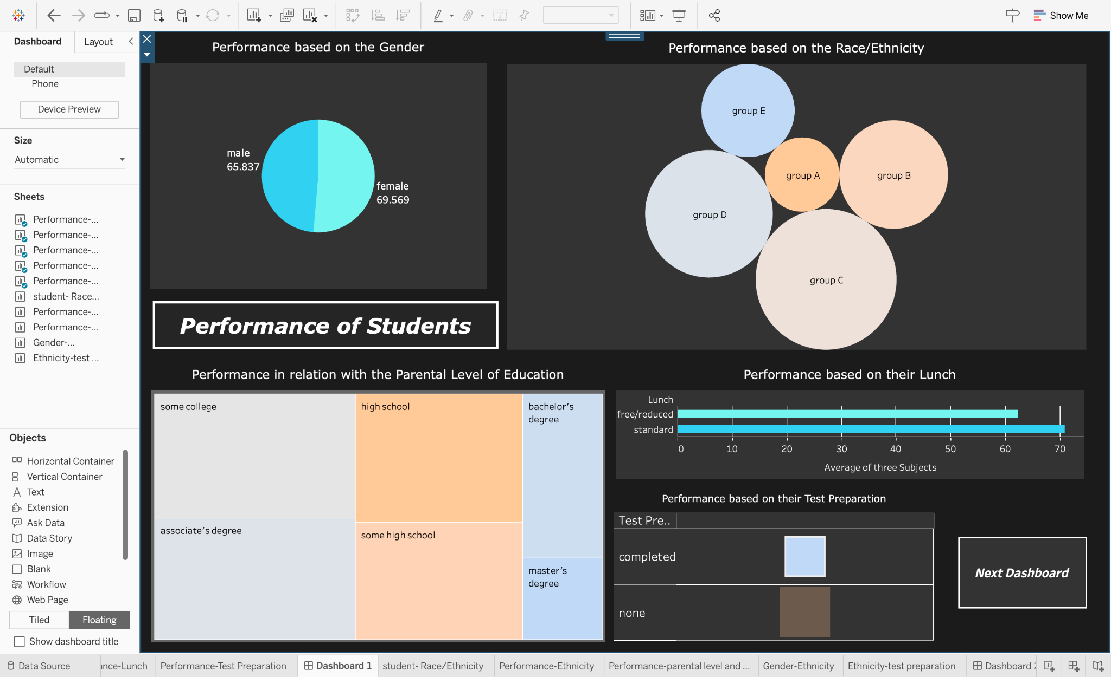

**Dashboard 2: How ethnicity/Race is related to the other parameters ?**

**Explanation video link:**

[Dashboard 2](https://drive.google.com/file/d/1GOgo2MbmFE_1IiQAcr6rfrGWyNsU1mT2/view?usp=sharing)

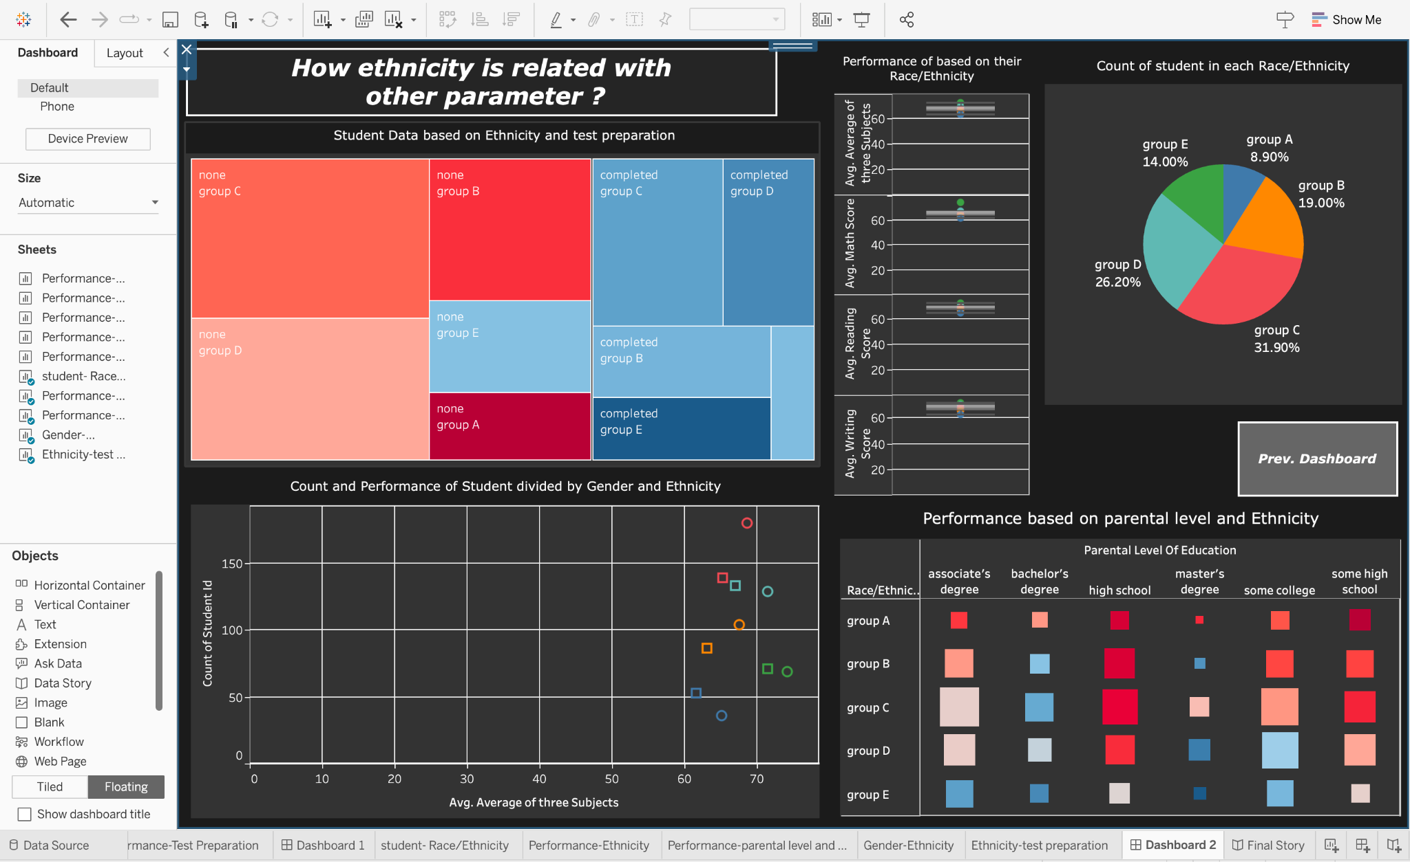

**Milestone 5: Story**

A data story is a way of presenting data and analysis in a narrative format, with the goal of making the information more engaging and easier to understand. A data story typically includes a clear introduction that sets the stage and explains the context for the data, a body that presents the data and analysis in a logical and systematic way, and a conclusion that summarises the key findings and highlights their implications. Data stories can be told using a variety of mediums, such as reports, presentations, interactive visualisations, and videos.

The story provides the variation in student’s performance based on different parameters. The story has a total of 9 visualisations and each visualisation has an interconnected meaning and all the visualisations are pointing toward the performance of students. From the whole story, it can be inferred that the females from group E with standard lunch whose parental level of education is Master’s degree and completed the test preparation have shown the most promising results.

**Activity 1: No of Scenes of Story**

The number of scenes in a storyboard for Data-Driven insights on Students Performance will depend on the complexity of the analysis and the specific insights that are trying to be conveyed. A storyboard is a visual representation of the data analysis process and it breaks down the analysis into a series of steps or scenes.

**Explanation video link:**

[**Story of Student's Performance**](https://drive.google.com/file/d/16bUnSFi_hQdlZd4YoBMUyMTEY1GQsONw/view?usp=sharing)

**1. Story of count percentage of student in each ethnicity/race:**

This is a pie chart. It demonstrates the percentage of students in each Ethnicity/Race. Different colours show different ethnicities. Based on this, it can be seen that Group C has the highest number of Students.

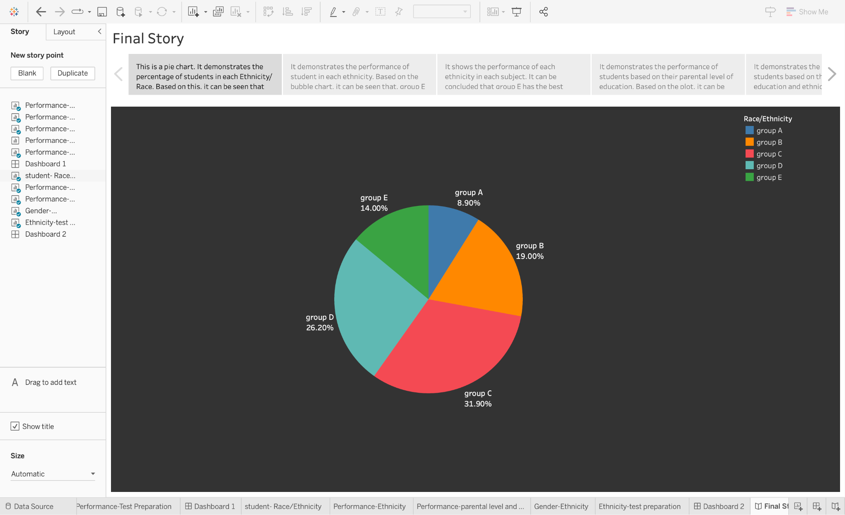

**2. Story of overall performance of student based on ethnicity/race:**

It demonstrates the performance of students in each ethnicity. Colour denotes the performance of the student and size denotes the number of students in each ethnicities. Based on the bubble chart, it can be seen that group E has the highest performance.

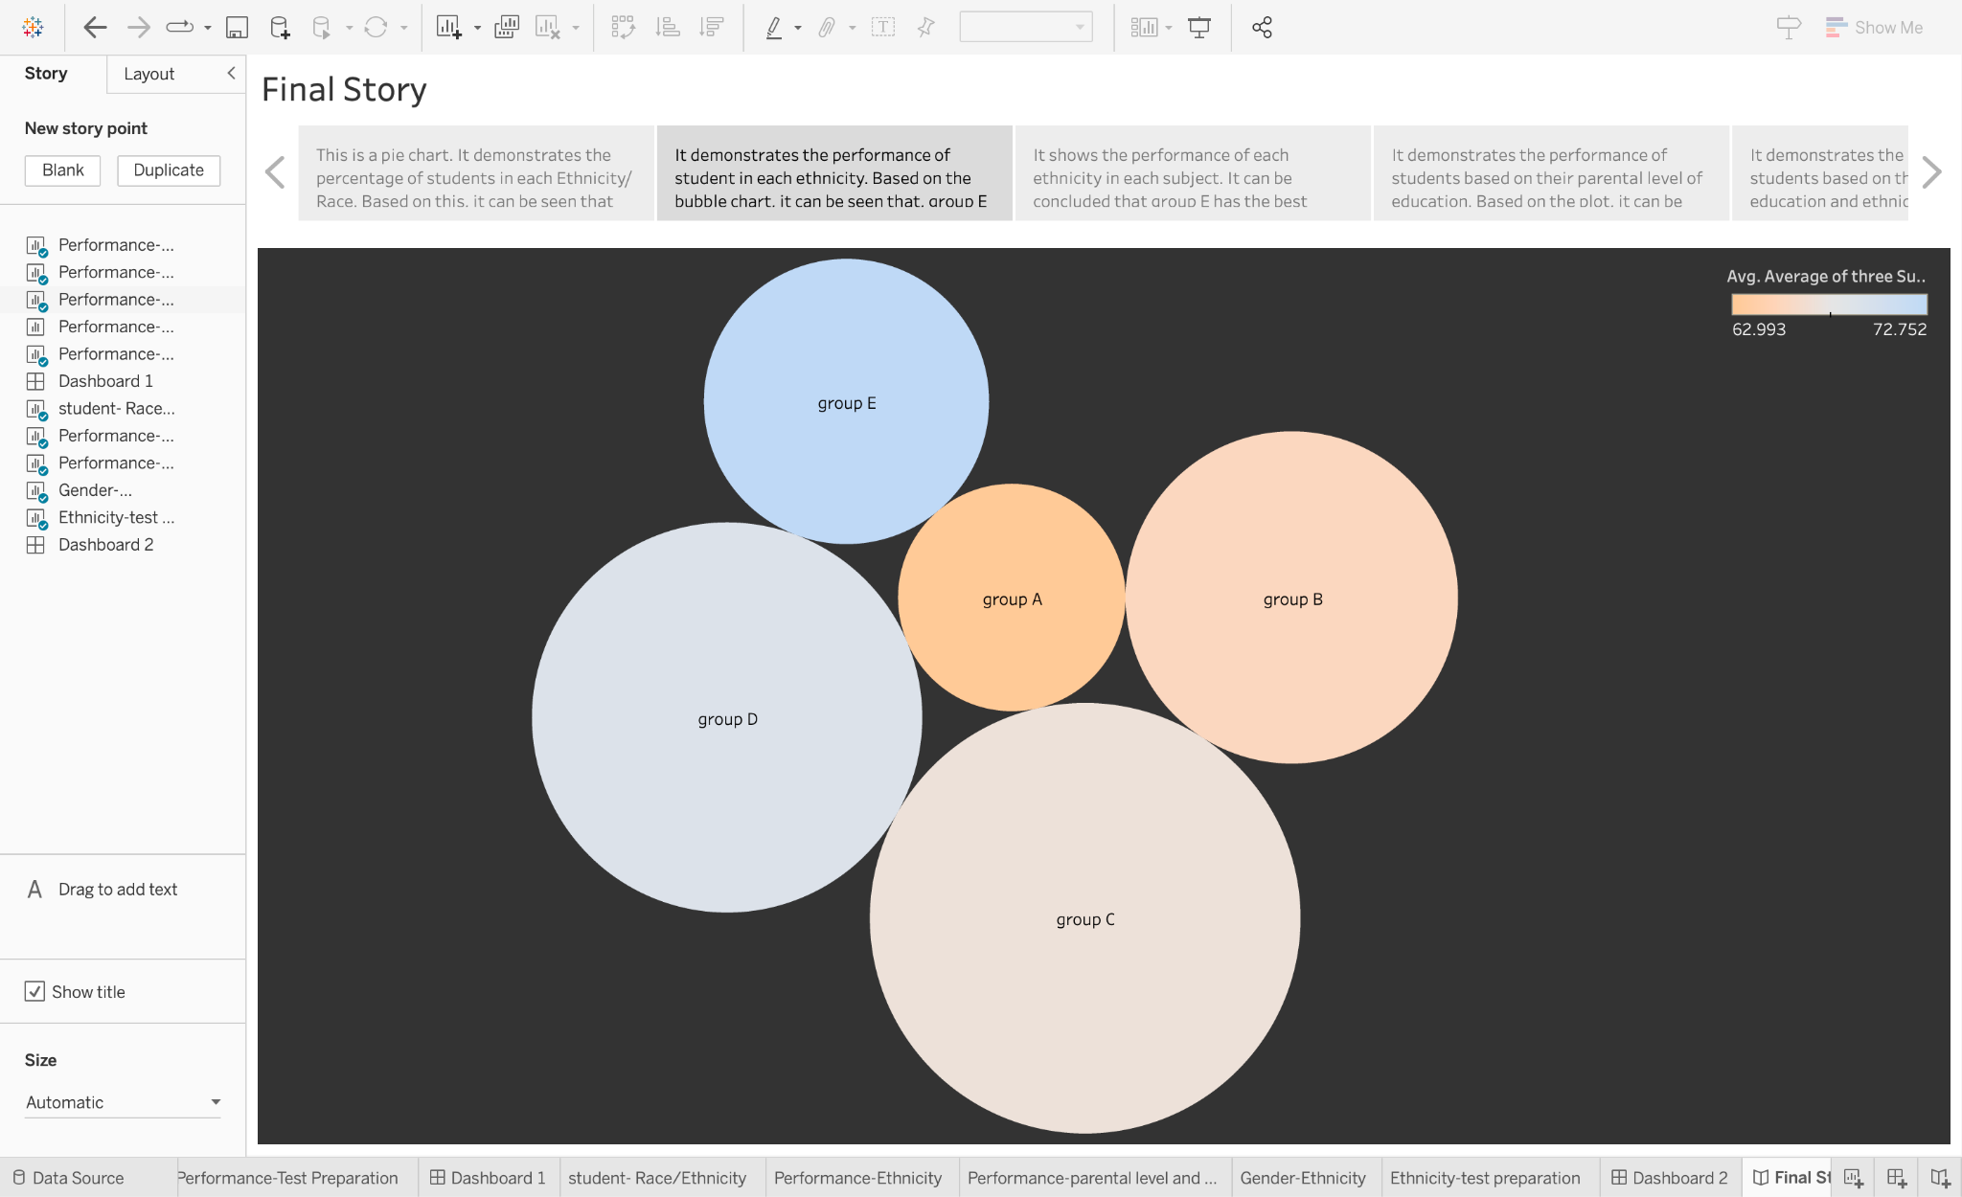

**3. Story of performance of student in each subject on the basis of ethnicity/race:**

This is a box and whisker plot. It shows the performance of each ethnicity in each subject. Colour denotes different ethnicities. It can be concluded that group E has the best performance and group A has the worst performance.

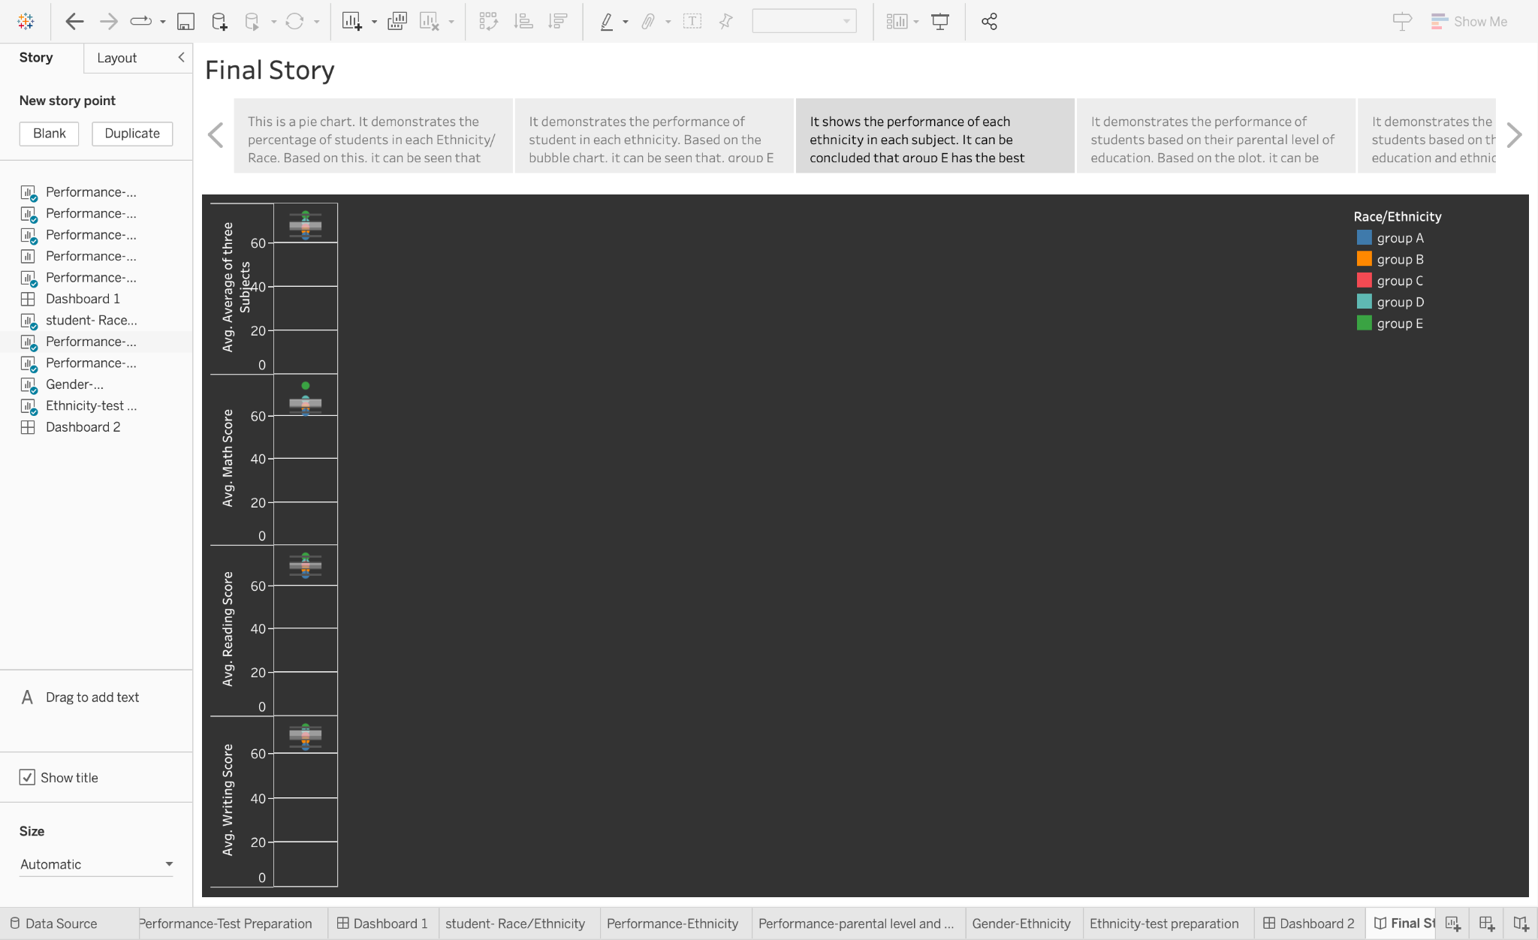

**4. Story of performance of student influenced by their parental level of education:**

This is a treemap. It demonstrates the performance of students based on their parental level of education. Colour denotes the performance of the student and size denotes the number of students based on the parental level of education. Based on the plot, it can be seen that students whose parental level of education is master's degree have the highest performance in spite of having the lowest count of students.

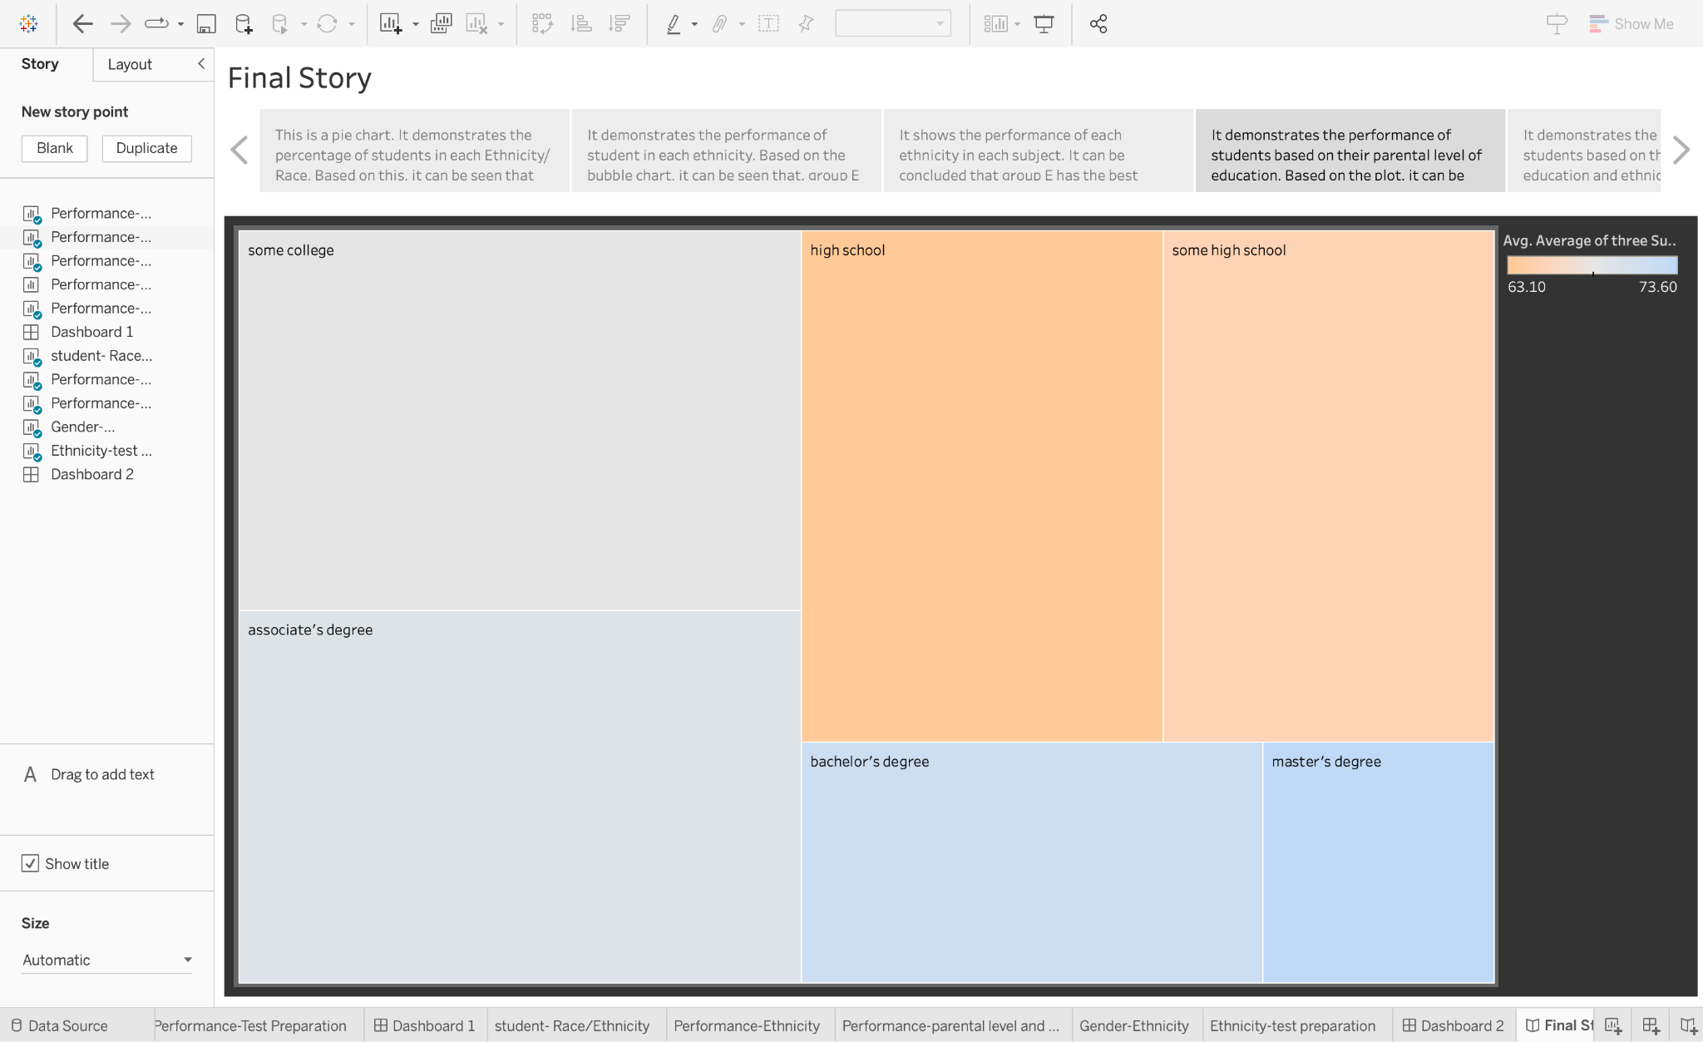

**5. Story of performance and count of student based on their parental level of education and ethnicity/race:**

It demonstrates the performance of students based on their parental level of education and ethnicity. Based on the heat map, it can be seen that students under group E and whose parental education level is master's degree have the highest performance.

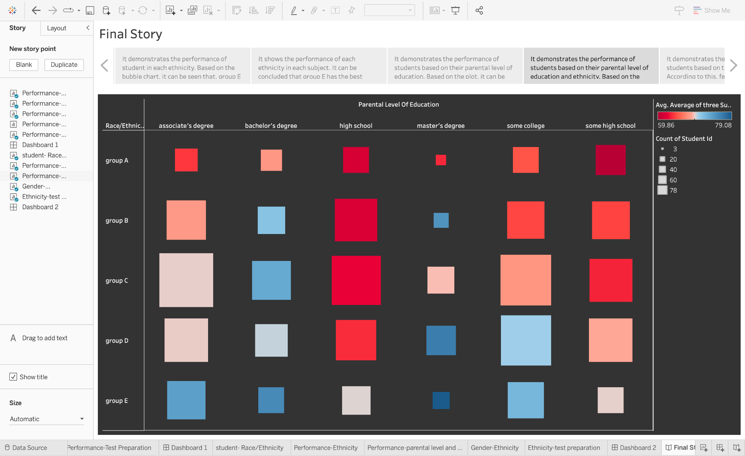

**6. Story of who is performing better males or females:**

It demonstrates the performance of students based on their gender. Colour denotes gender. According to this, females are performing better than males.

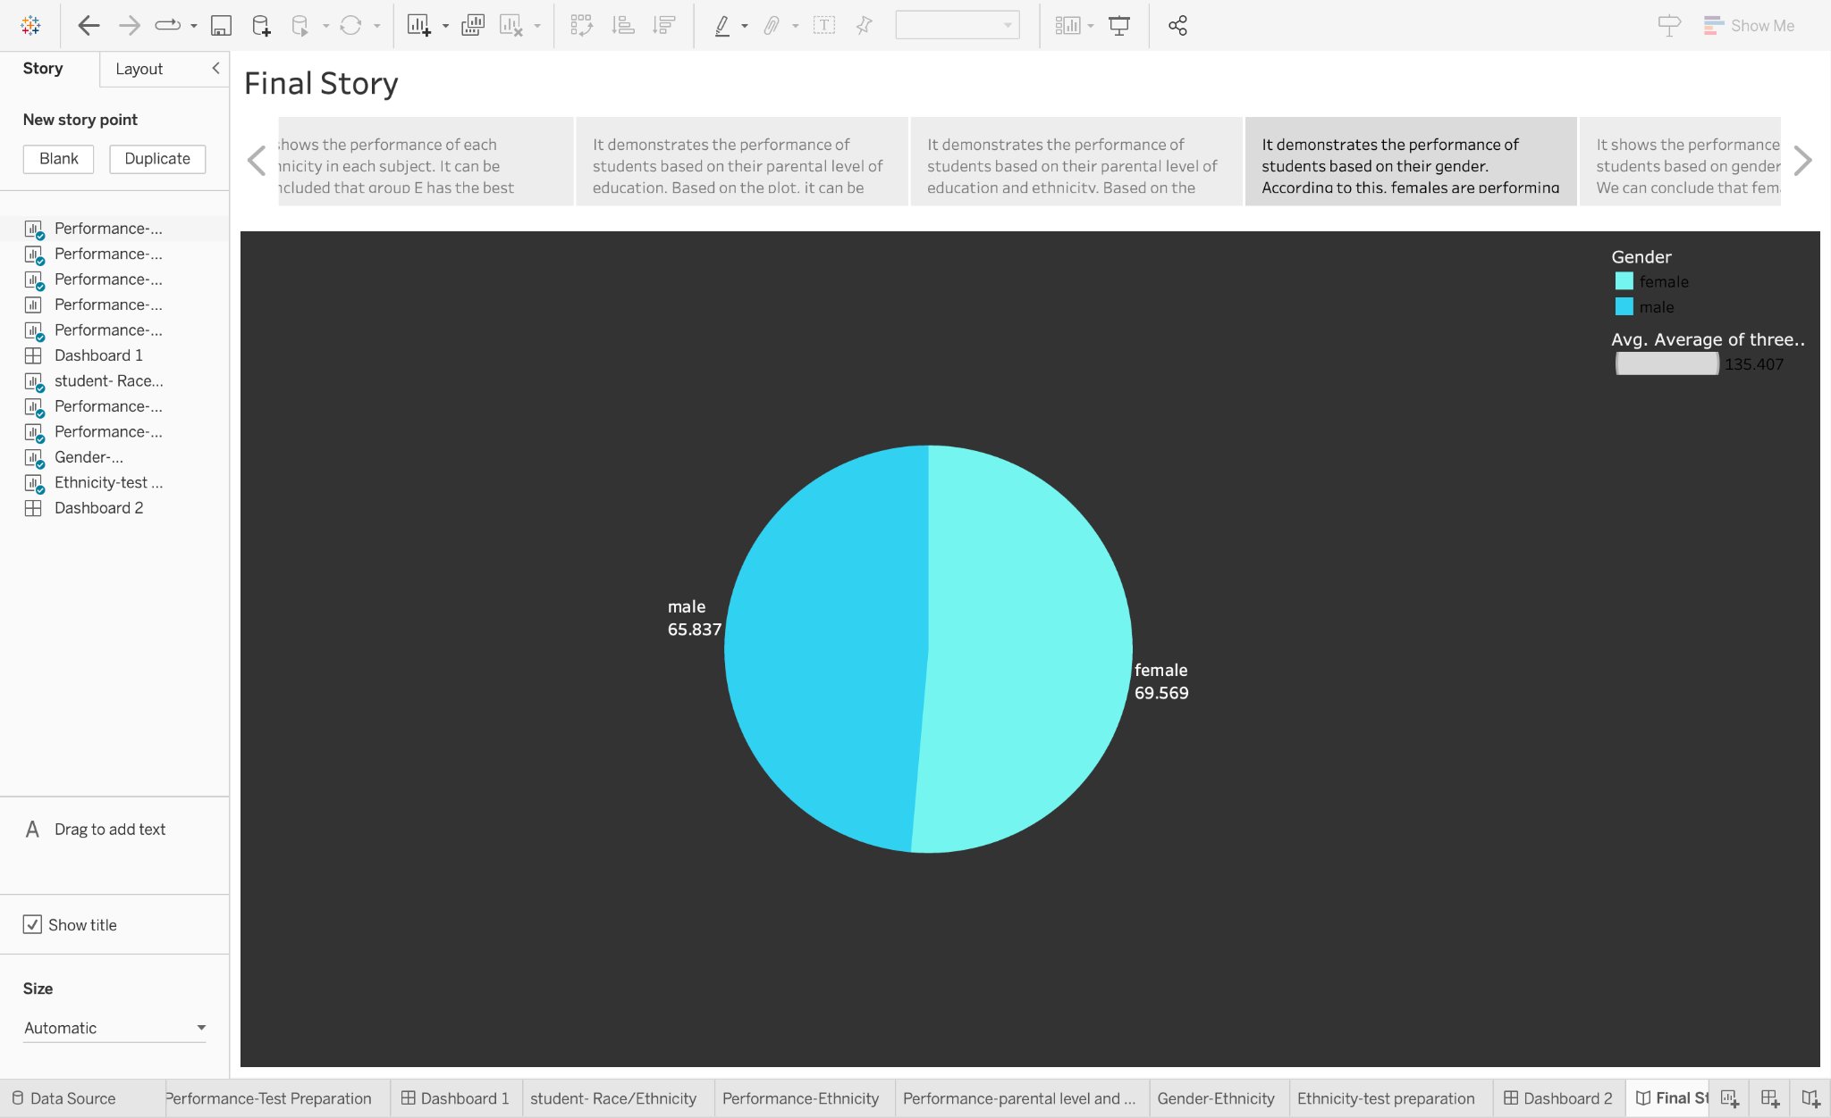

**7. Story of performance and count of student based on their gender and ethnicity/race:**

It shows the performance and count of students based on gender and ethnicity. Different shapes denote gender and colour denotes the ethnicities. We can conclude that females are performing better in each ethnicity.

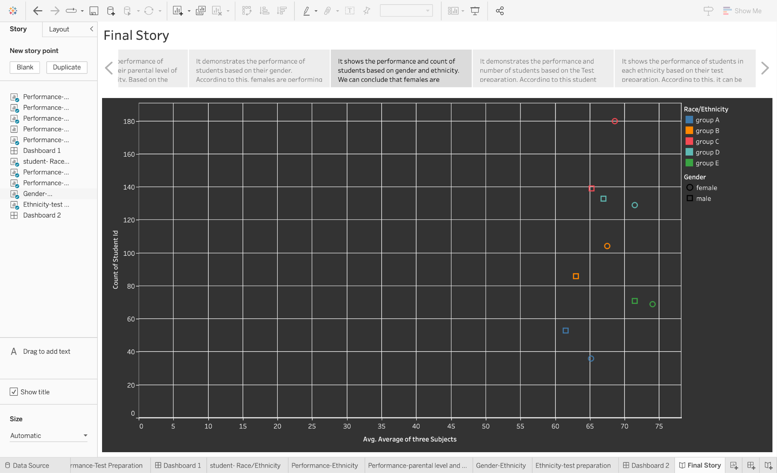

**8. Story of variation of performance on the basis of test preparation:**

It demonstrates the performance and number of students based on the Test preparation. Colour denotes the average score and size shows the count of the student ids. According to this student who had been prepared for the test performed better in spite of less count of students.

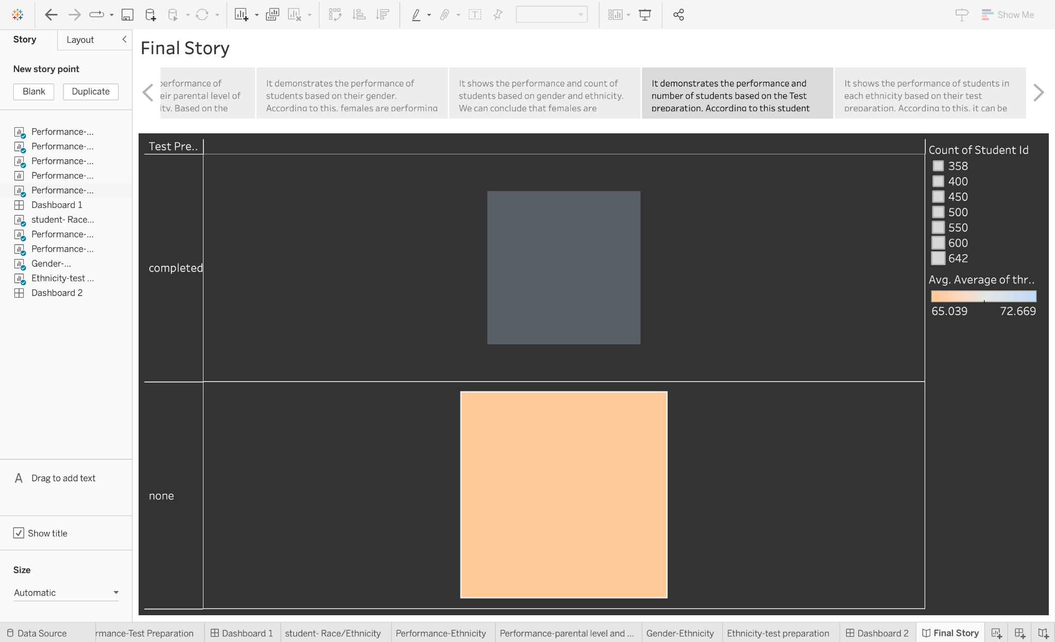

**9. Story of performance student affected by test preparation and ethnicity/race:**

It shows the performance of students in each ethnicity based on their test preparation. Colour denotes the average score and size shows the count of the student ids in each ethnicities. According to this, it can be seen that group E with the completed test preparation has the highest performance.

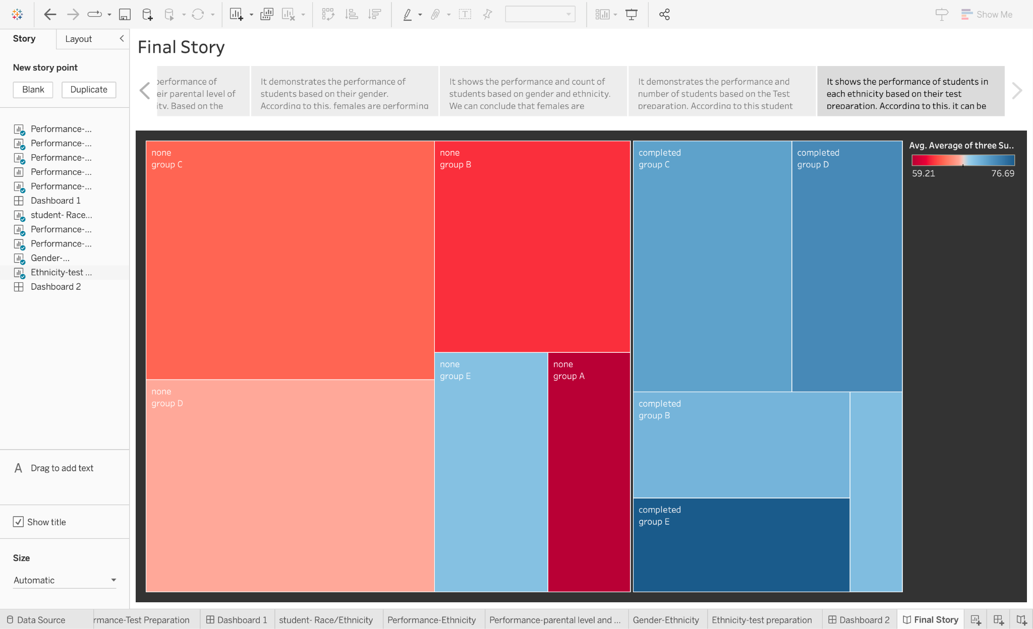

**Milestone 6: Performance Testing**

Performance testing is a type of software testing that evaluates how a system or application performs under different workloads and conditions. The goal of performance testing is to identify any performance issues or bottlenecks that may exist and to determine whether the system can handle its expected workload.

**Activity 1: No of Calculation Field**

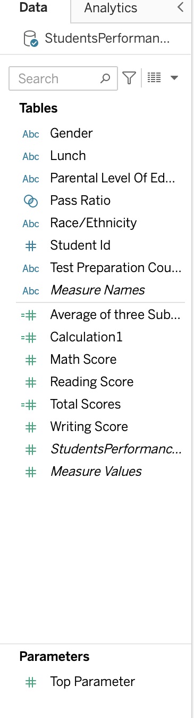

**Activity 2: No of Visualization/Graphs**

1. Activity 1.1: Finding whether females perform better or males?
2. Activity 1.2: Finding how the parental level of education affects the performance of the student ?
3. Activity 1.3: Find the performance of students with the ethnicity/race?
4. Activity 1.4: Find the performance of students based on whether the lunch is free or standard ?
5. Activity 1.5: Find the performance on the basis of test preparation ?
6. Activity 1.6: Find the number of students in each ethnicity ?
7. Activity 1.7: Finding the performance of students in each subject with respect to their ethnicity?
8. Activity 1.8: Find which group of students performing best on the basis of parental level of education and ethnicity ?
9. Activity 1.9: Finding which gender is performing better under the influence of the ethnicity ?
10. Activity 1.10: Finding how ethnicity is affected by test preparation ?

**Milestone 7: Web Integration**

Publishing helps us to track and monitor key performance metrics, to communicate results and progress. help a publisher stay informed, make better decisions, and communicate their performance to others.

**Integrating dashboard/stories to web:**

[**Publishing/Integrating story and Dashboard**](https://drive.google.com/file/d/1shKZafjsEgFQkPipbyUGaGxp9NnD7Yd3/view?usp=sharing)

**Activity 1: Dashboard and Story embed with UI With Flask**

1. You have to publish your sheet in your tableau public Account.
2. Once you publish it, get the link as shown in the video below and paste it in your html code.
3. Then, the sheets are displayed.

**Dashboard:**

**Explanation video link:**

[**Embedding Dashboard using Flask**](https://drive.google.com/file/d/1YQlj7jffHkGJC40KH_IXzU7h6k8CvFtM/view?usp=sharing)

**Story:**

**Explanation video link:**

[**Embedding Story using Flask**](https://drive.google.com/file/d/1R0j5smPQGeTtr6QUamRtNR8NC4Y2x2qf/view?usp=sharing)

**Flask:**

**Explanation video link:**

[**Flask Explanation**](https://drive.google.com/file/d/1og08a-gosTxptEG98UD-sWfZcol9BUs4/view?usp=sharing)

***5. FLOWCHART***

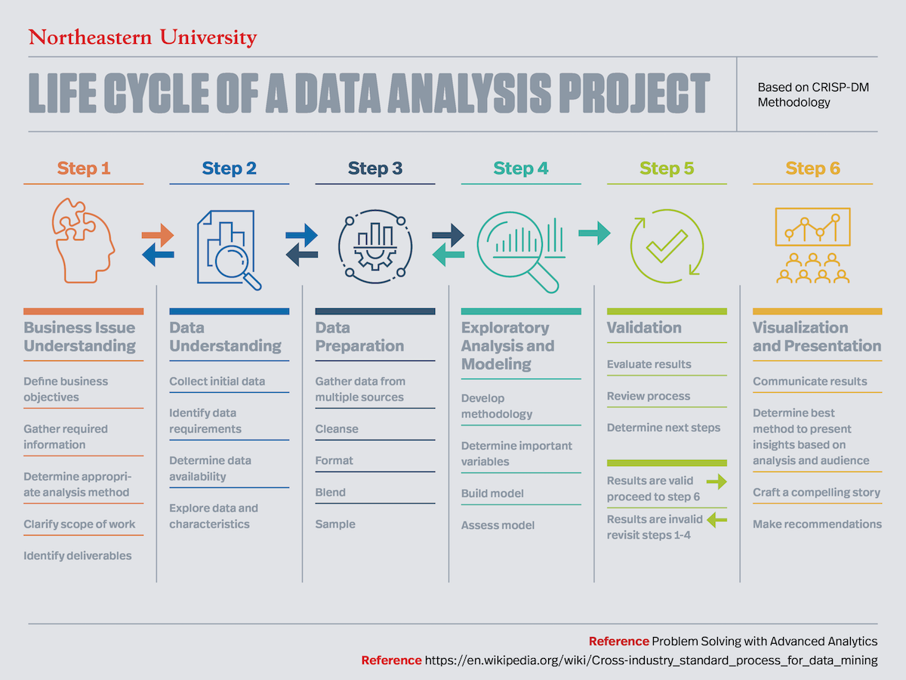

**Block Diagram of Flow of Project**

***6. RESULT***

The results are promising and astonishing as, it can be seen that

* On the basis of gender, females are performing better than males;
* On the basis of parental level of education, student’s whose parents having master’s degree are showing the best performance;
* On the basis of ethnicity and race, group E had the most promising results;
* On the basis of test preparation, student who had been prepared for the test are showing the better results;
* On the basis of lunch, students who are having standard lunch are showing better results;
* On the basis of the scores in three subjects, the average reading score is best, then comes the average writing score and in the last comes is the average maths score.

Dashboard 1 provides the information about the students’ performance with respect to each domain, and it shows the same results as inferred above.

Dashboard 2 provides information about how ethnicity is related with each other dimensions. It shows the largest number of students are from Group C. Students from Group A are performing the worst in all scenarios and students from Group E are performing the best. Females are performing best in each group. Students who have completed the test preparation are performing the best from each group. Students from group E whose parental level degree is Master’s degree are the best performers.

Story provides information about the student’s performance. From the whole story, it can be inferred that the females from group E with standard lunch whose parental level of education is Master’s degree and completed the test preparation have shown the most promising results.

***Snapshots of the Sheets :-***

1. Finding whether females perform better or males?

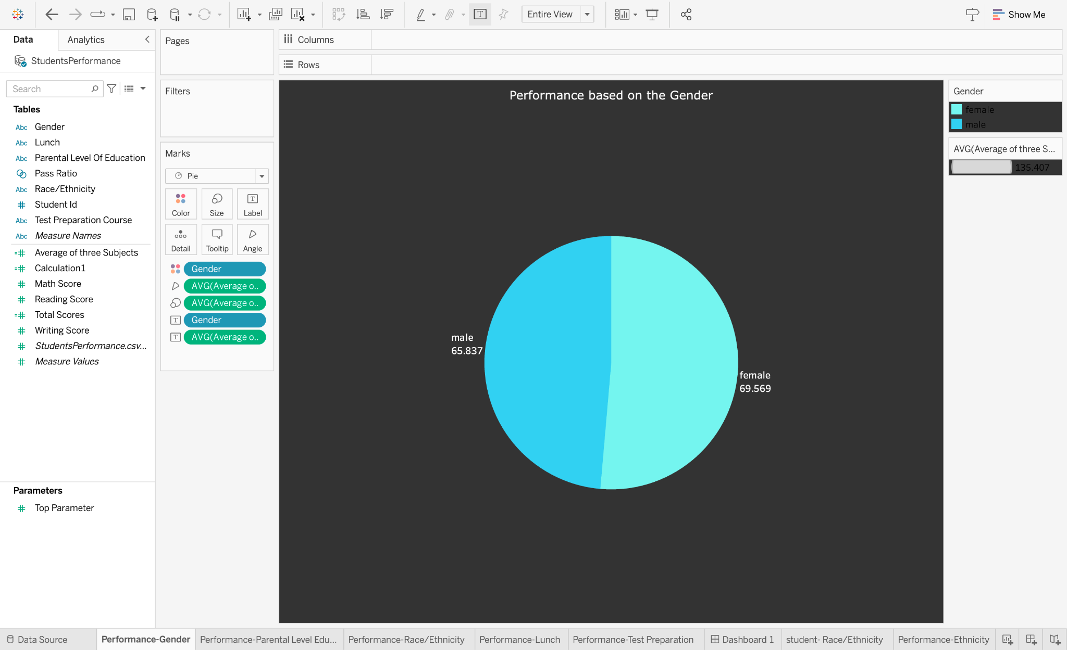

1. Finding how the parental level of education affects the performance of the student ?

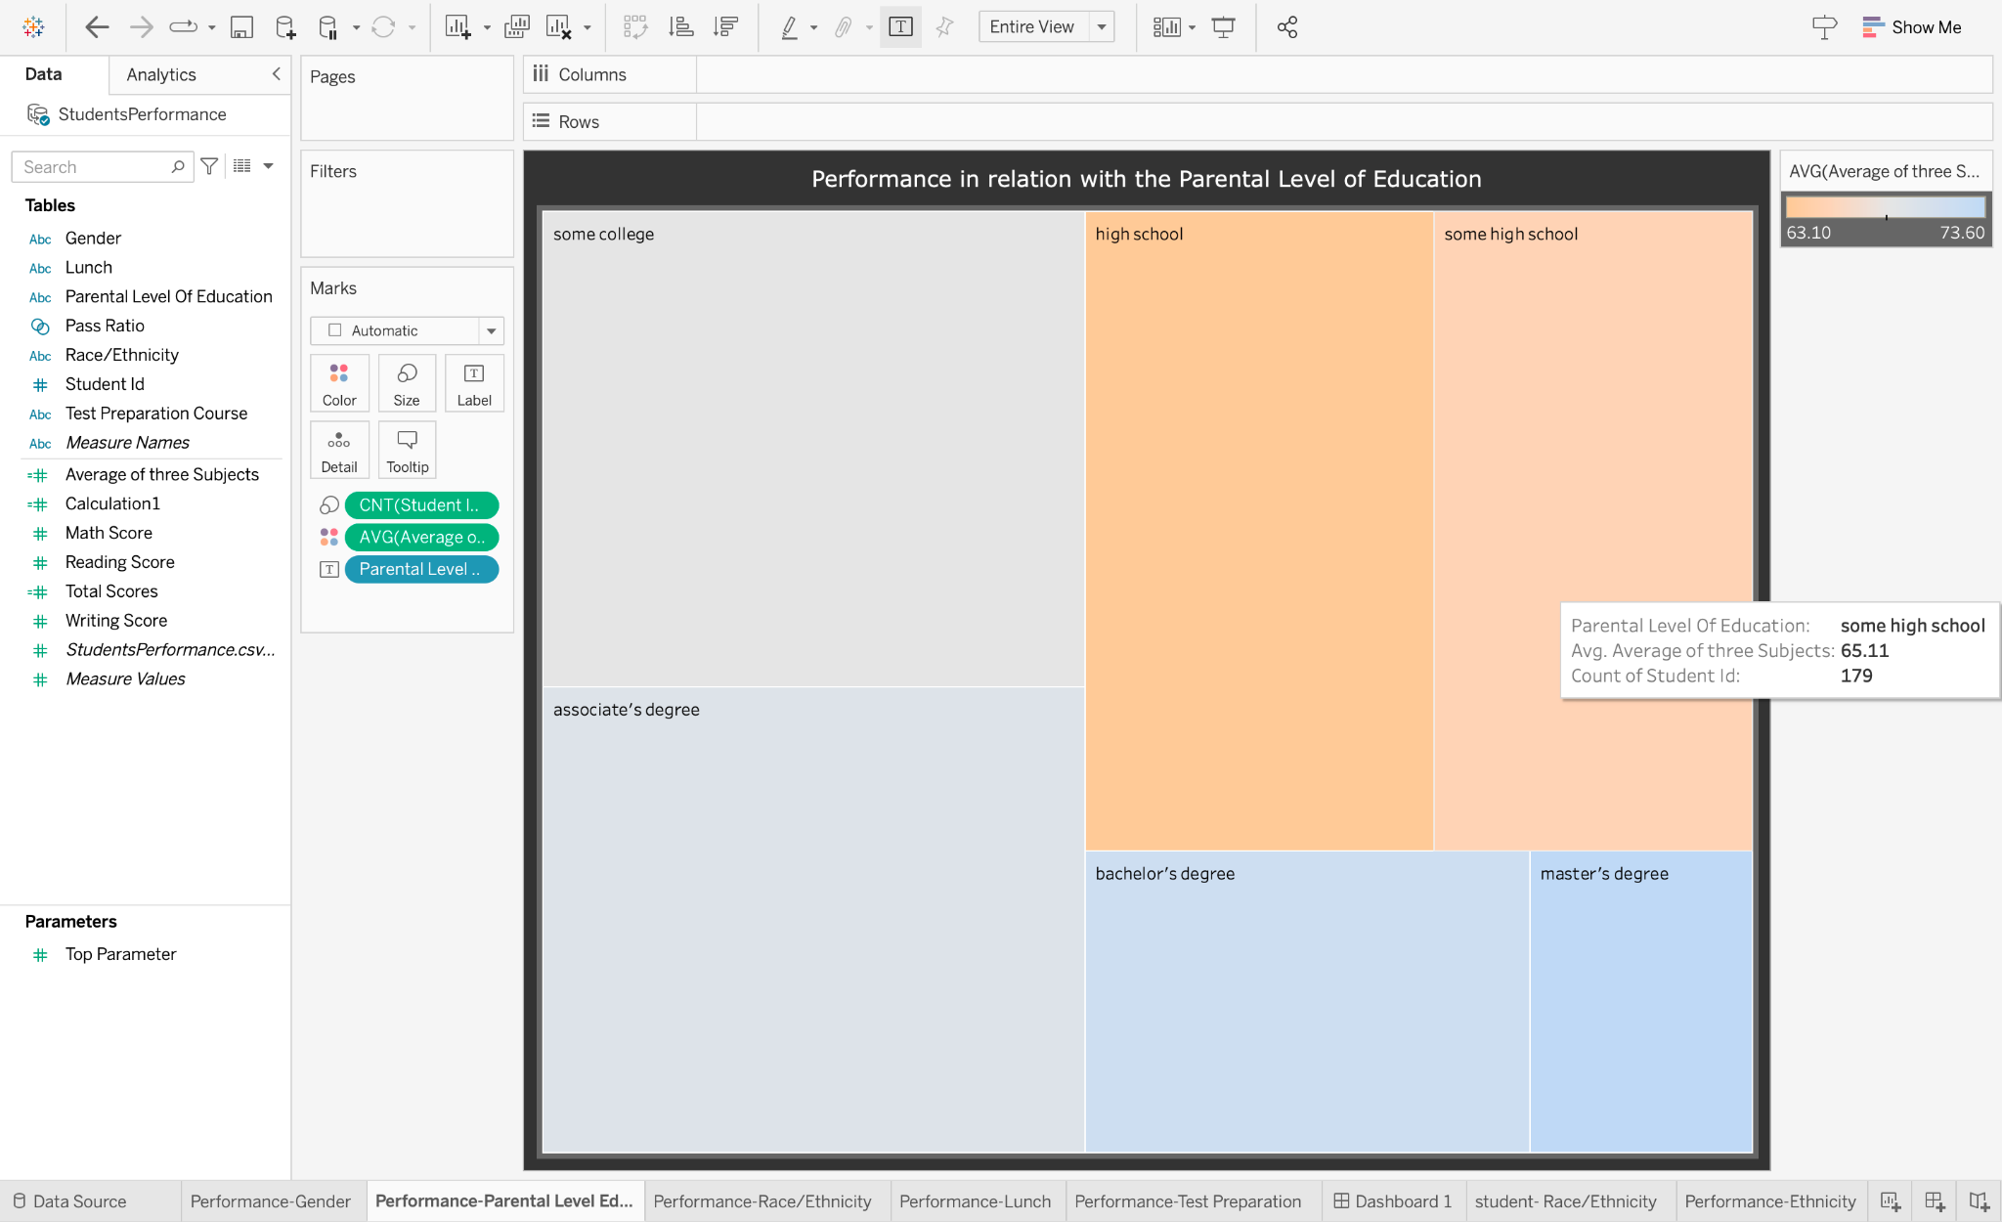

1. Find the performance of students with the ethnicity/race?

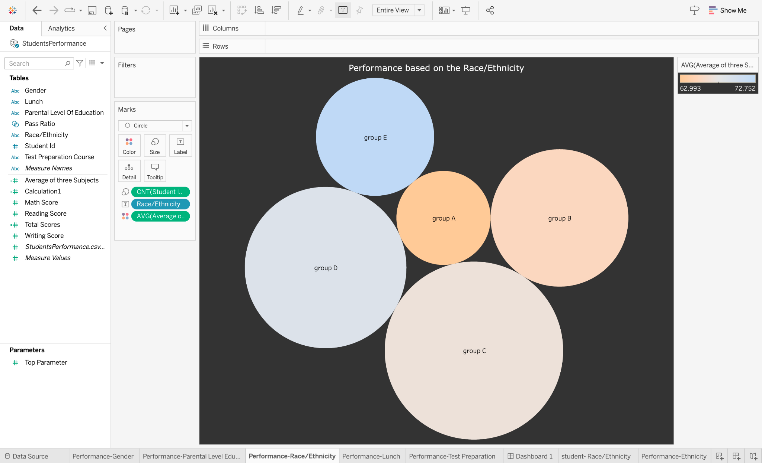

1. Find the performance of students based on whether the lunch is free or standard ?

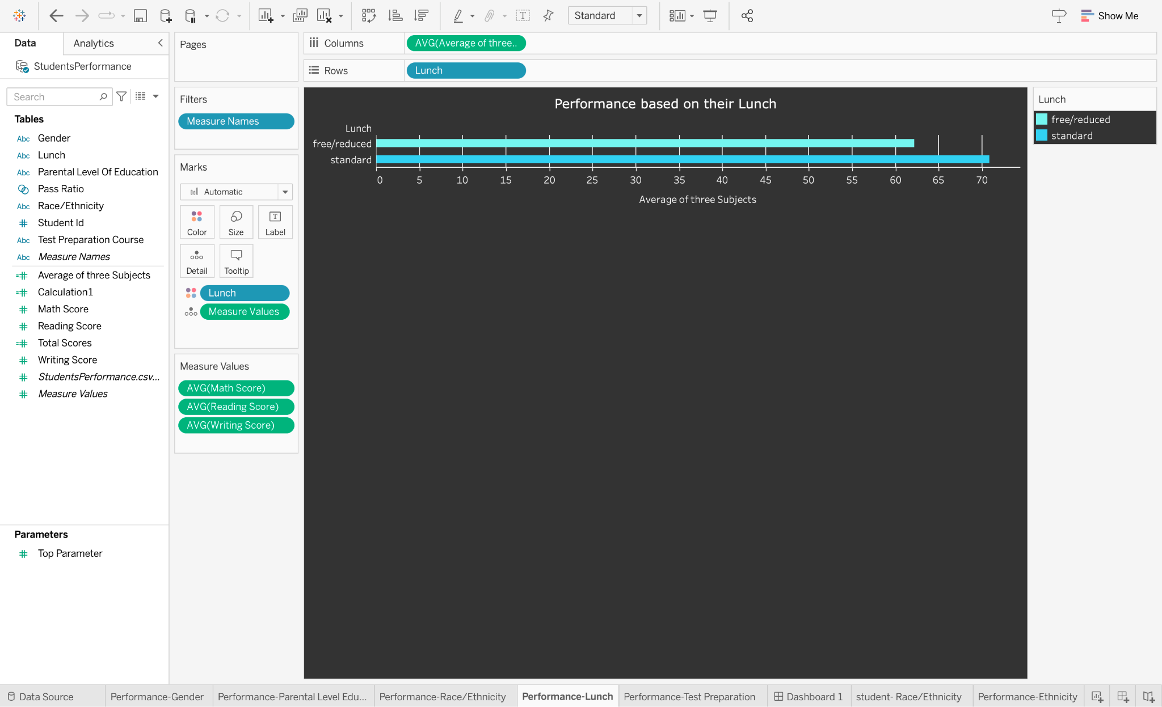

1. Find the performance on the basis of test preparation ?

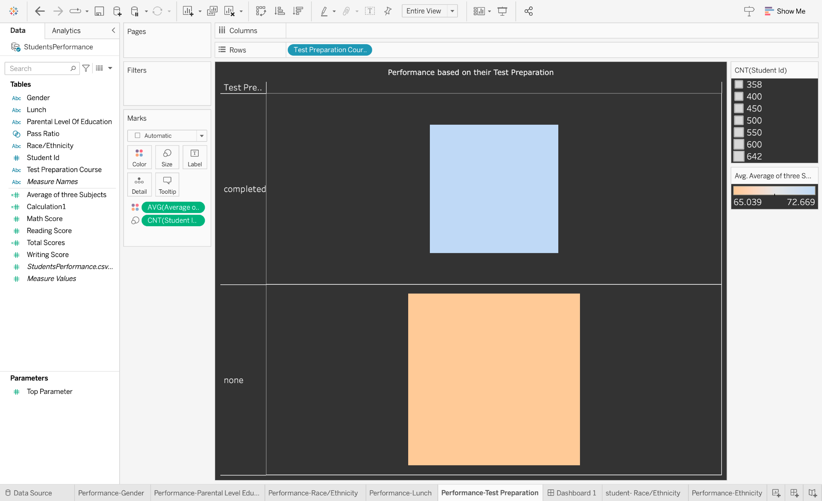

1. Find the number of students in each ethnicity ?

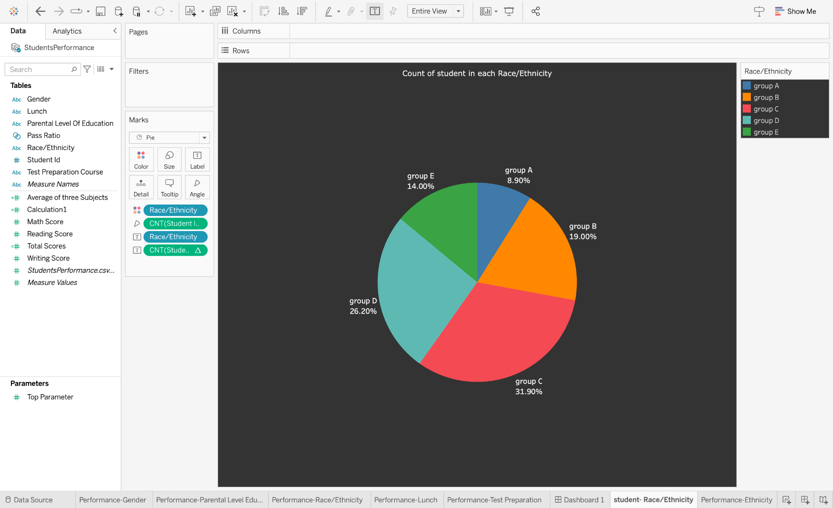

1. Finding the performance of students in each subject with respect to their ethnicity?

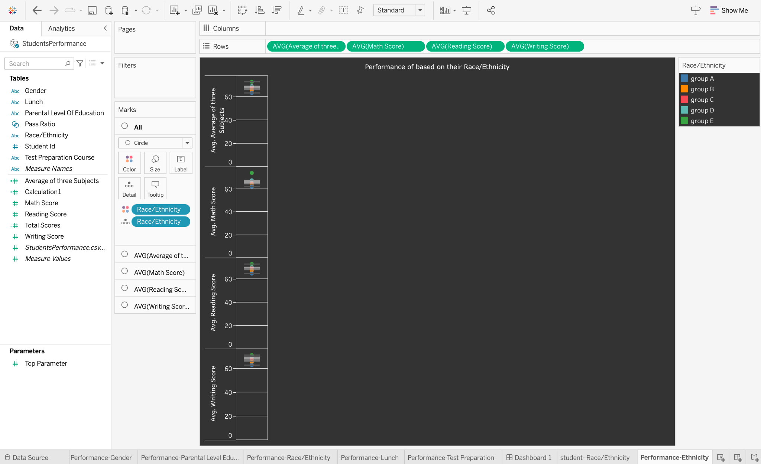

1. Find which group of students performs best on the basis of parental level of education and ethnicity ?

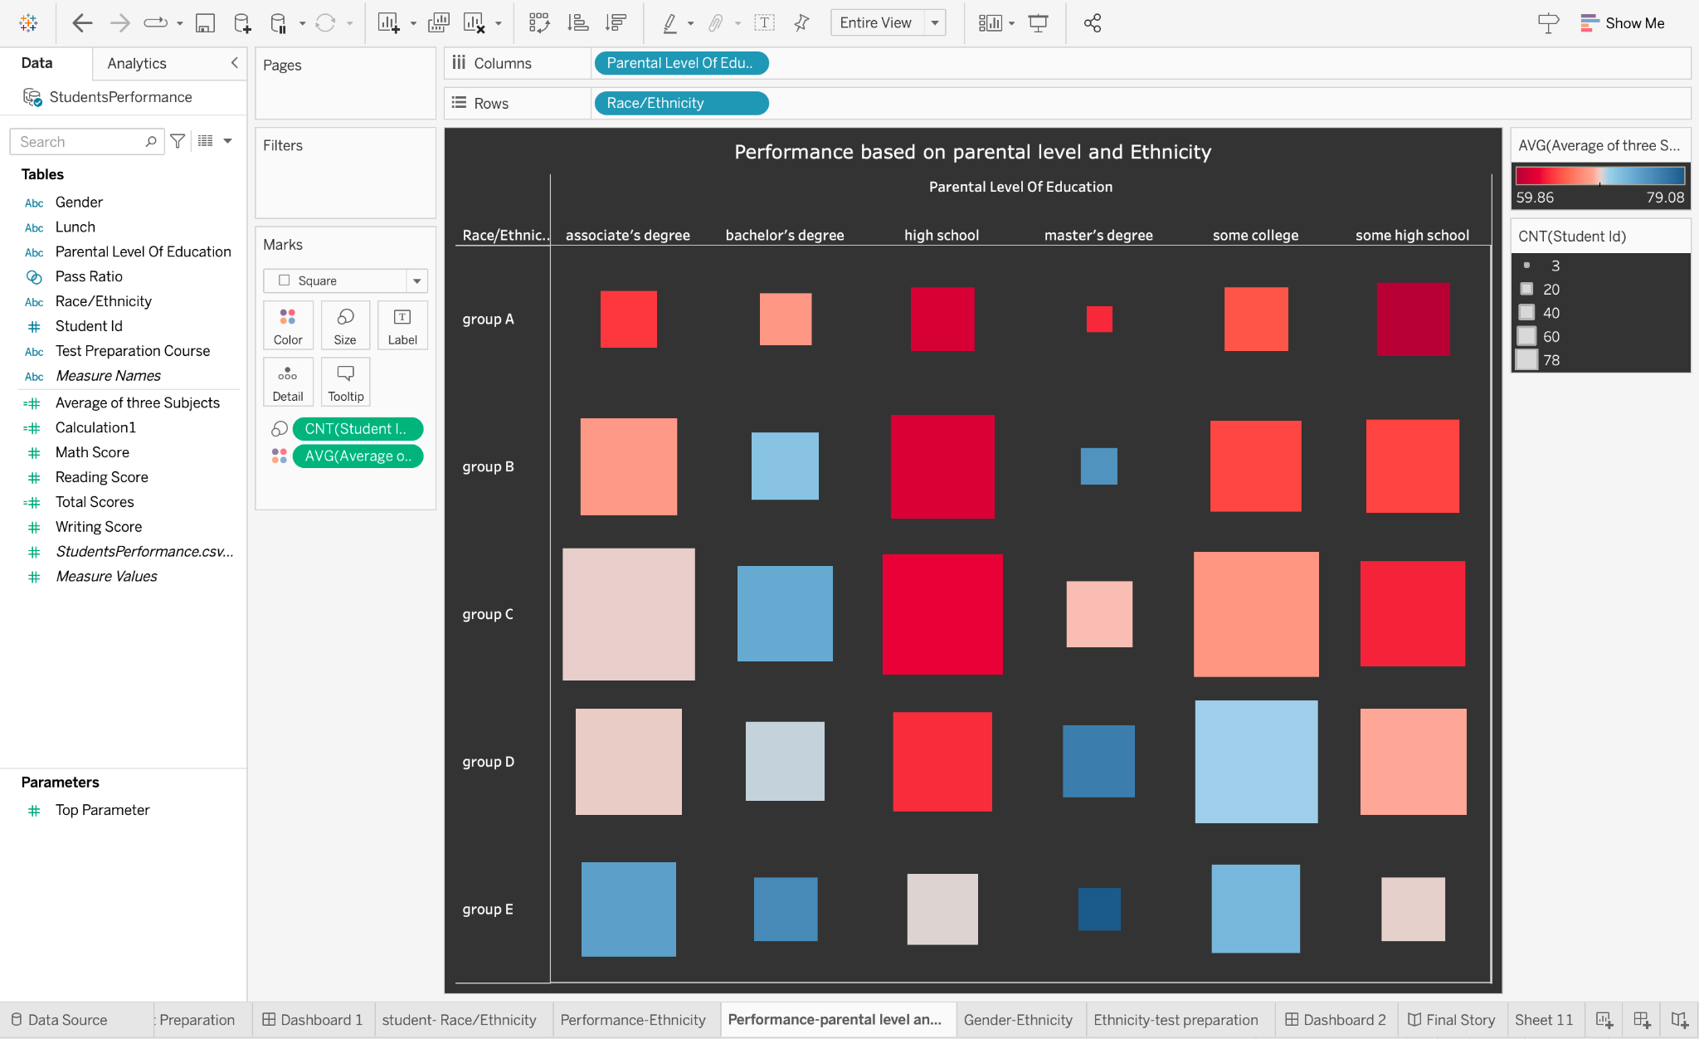

1. Finding which gender is performing better under the influence of the ethnicity ?

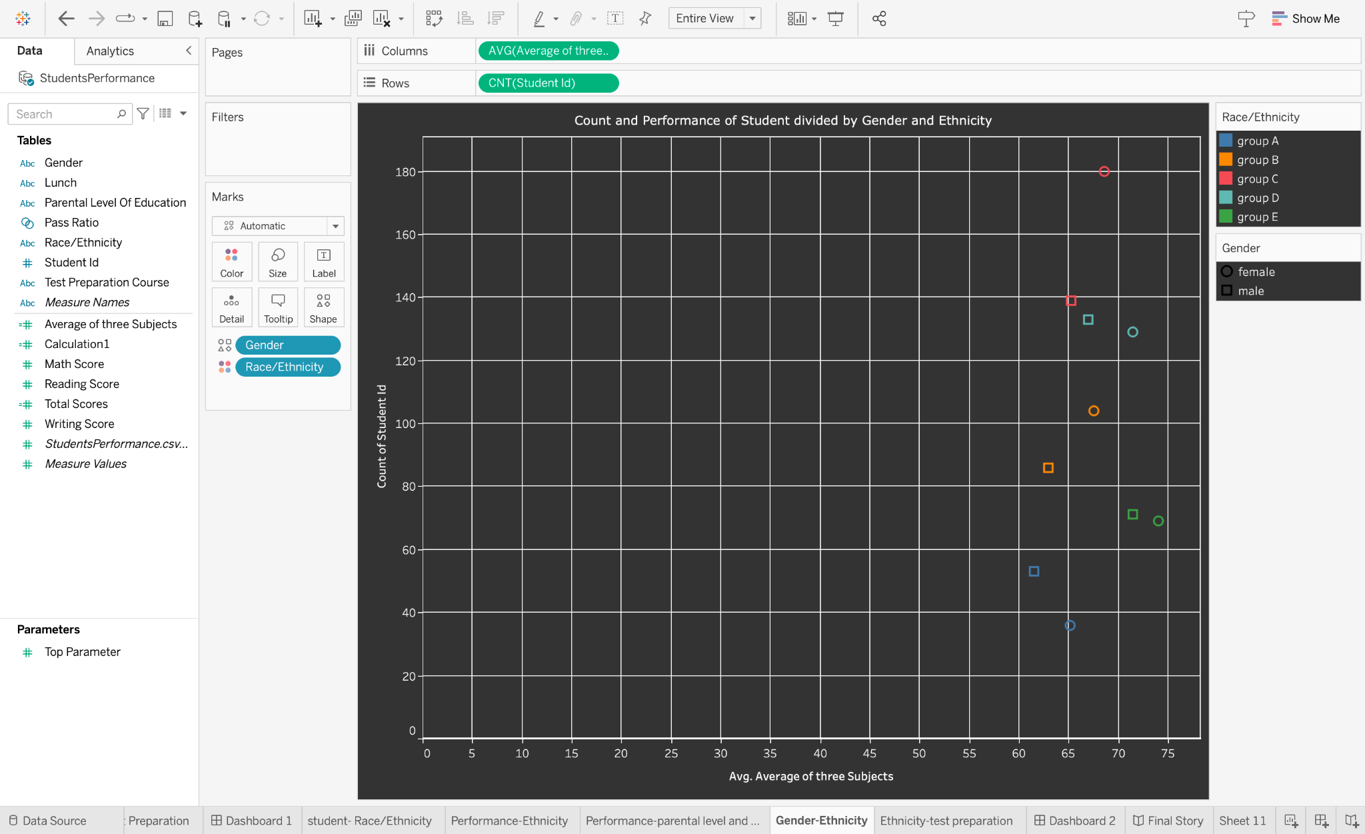

1. Finding how ethnicity is affected by test preparation ?

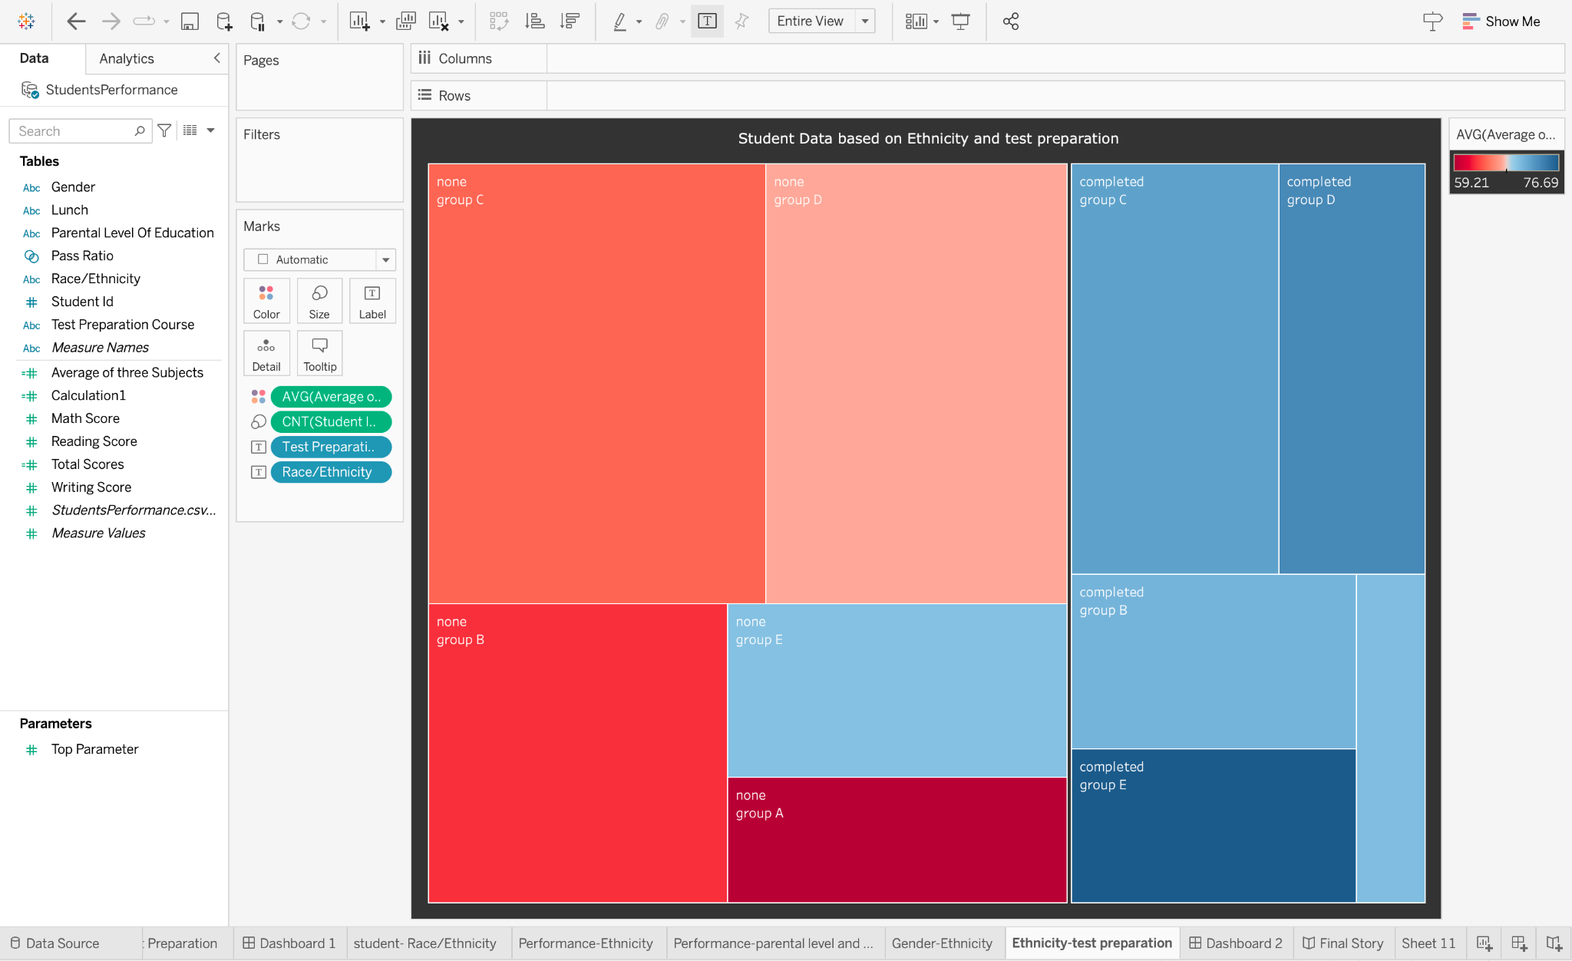

***Note : -***

1. ***Explanation of the sheets are done in milestone 3.***
2. ***Snapshots and explanation of the dashboard and story are shown in milestones 4 and 5.***

***7. ADVANTAGES & DISADVANTAGES***

**Advantages:**

1. **Data-Driven Insights:** The proposed solution leverages data analytics techniques to provide valuable insights into student performance. By analysing comprehensive datasets, it enables stakeholders to understand the factors influencing student success and make informed decisions based on evidence rather than assumptions.
2. **Early Intervention:** Predictive analytics helps identify at-risk students early on, allowing for proactive interventions. By recognizing patterns and warning signs, educators and support systems can provide timely and targeted assistance, improving the chances of academic success for struggling students.
3. **Personalised Learning:** The project enables personalised learning approaches by tailoring instruction and support to individual student needs. By understanding students' strengths, weaknesses, and learning preferences, educators can create customised learning plans that maximise engagement and promote better academic outcomes.
4. **Collaboration and Partnerships:** A student performance analysis encourages cooperation between stakeholders, such as educators, decision-makers in the public sector, parents, and members of the community. Together, they can build an atmosphere that fosters and nurtures student potential by utilising their combined knowledge and resources.
5. **Evidence-based Decision Making:** Stakeholders may reach well-informed, evidence-based judgements by examining student performance data and spotting trends and patterns. This makes it possible for educators, decision-makers, and parents to put into practise targeted interventions and tactics that successfully unlock the potential of students.

**Disadvantages:**

1. **Data Quality and Availability:** The success of the project relies heavily on the quality and availability of data. Inaccurate or incomplete data can lead to biased or unreliable analysis outcomes. Ensuring data quality and addressing data gaps and limitations may pose challenges, especially when dealing with data from diverse sources or when data collection processes are not standardised.
2. **Privacy and Ethical Considerations:** The project involves handling sensitive student data, raising concerns about privacy and ethical considerations. Safeguarding student privacy and ensuring compliance with data protection regulations is of utmost importance. Anonymization and appropriate security measures must be implemented to protect student information.
3. **Overemphasis on Quantitative Measures:** When analysing student achievement, it is frequently quantitative metrics—like grades or test results—that are used, which may not fully reflect student potential. This strategy could neglect important qualities like originality and interpersonal skills, and leadership abilities, which are also important for unleashing student potential.
4. **Interpretation and Bias:** Analysing student performance data involves interpretation and may be subject to biases or misinterpretation. Interpretation of results should be done with caution, considering multiple perspectives and expert guidance. Biases may also exist in the data collected for student performance analysis.
5. **Implementation and Adoption:** Translating the insights gained from data analysis into actionable strategies and ensuring their effective implementation at the ground level may be a challenge.

***8. APPLICATIONS***

A student performance analysis may be used in a variety of real-world situations to help young people reach their full potential. A few significant uses are:

1. **Education Policy Development:** Using the study as a guide, local, regional, or national education policy can be created. By comprehending the factors that influence student potential, policymakers can build evidence-based policies that promote equitable access to high-quality education, promote holistic development, and resolve challenges and roadblocks.
2. **Student Support Systems:** The study can assist educational institutions in setting up efficient student support systems. It can guide the establishment of mentoring programmes, counselling services, and extracurricular activities that support personal growth, wellbeing, and the discovery of abilities and interests.
3. **Targeted Interventions and Support:** Based on their individual needs, the solution provides customised interventions for at-risk kids. It can shed light on the subjects where students need more help, such as tutoring, mentoring, therapy, or specific learning opportunities. The solution addresses learning gaps, boosts student performance, and enhances academic results by providing personalised support.
4. **Parental Involvement and Support:** The analysis can help parents learn how to encourage their kids' growth and help them reach their full potential. It can shed light on the value of active parental participation, clear communication, and fostering a supportive home environment that promotes education, adventure, and individual development.
5. **Continuous Improvement and Assessment:** The solution enables continuous evaluation and monitoring of student performance. Teachers and administrators can monitor development, assess the success of interventions, and pinpoint areas for development by assessing data over time. Continuous development based on data-driven insights aids in the optimisation of educational practices and guarantees that interventions are flexible enough to meet changing student demands.
6. **Resource Allocation and Funding Prioritisation:** The study can help educational systems prioritise their use of resources. It can aid in identifying areas that need more funding, such as those for infrastructure development, teacher training, technological access, or extracurricular resources.

***9. CONCLUSION***

The project on "Unleashing the Potential of Our Youth: A Student Performance Analysis" demonstrates the power of data analytics in transforming education and unlocking the full potential of our youth. Through the comprehensive analysis of student performance data, the project has provided valuable insights into the factors influencing academic success and has offered evidence-based solutions to drive positive change in the education sector.

By leveraging data analytics techniques, the project has enabled personalised learning approaches that tailor instruction and support to individual student needs. Early identification of at-risk students has facilitated targeted interventions, ensuring timely support and preventing academic challenges. The project has also highlighted the importance of equitable resource allocation, ensuring that funding, personnel, infrastructure, and educational materials are directed where they are most needed.

Furthermore, the project has contributed to evidence-based policy making in education. The insights gained from the analysis have informed the design and implementation of initiatives that address educational inequalities and enhance overall educational outcomes. By relying on data-driven insights, stakeholders can make informed decisions that have a measurable and positive impact on student performance and success.

It is important to acknowledge the challenges faced during the project, such as ensuring data quality, addressing privacy concerns, and fostering collaboration among stakeholders. Overcoming these challenges requires a collaborative effort and a commitment to data privacy and ethical considerations.

In conclusion, the project on "Unleashing the Potential of Our Youth: A Student Performance Analysis" has demonstrated the immense potential of data analytics in revolutionising education. By leveraging data-driven insights, personalised learning approaches, early intervention strategies, equitable resource allocation, and evidence-based policy making, we can create an inclusive and effective educational system that empowers our youth to thrive academically and fulfil their potential. Through continued dedication to data analytics and evidence-based decision making, we can pave the way for a brighter future, where every student has the opportunity to succeed and contribute meaningfully to society.

***10. FUTURE SCOPE***

In order to release the potential of our children, continuing study and constant improvement are built upon an examination of student performance. The analysis presents several possibilities for further research and development, including:

* Studies that are longitudinal can shed light on the long-term effects of educational interventions on the potential of students. Monitoring students' growth over a long period enables a greater comprehension of the elements that contribute to their success and development.
* The confluence of different characteristics, including gender, ethnicity, socioeconomic background, and disability in connection to student potential, might be explored in future evaluations of student performance. Developing more inclusive tactics and treatments requires an understanding of how these overlapping identities affect educational results.
* **Technology Integration:** Examining how technology might help students reach their full potential is part of the future scope of student performance analysis. Investigating how online platforms, data analytics, and digital learning technologies may enhance student engagement and performance is part of this.
* **Global and Cross-Cultural Perspectives:** Research that compares individuals from various nations and cultural backgrounds can shed light on the most efficient ways to maximise student potential. The creation of international frameworks and best practices may be influenced by gaining an understanding of the cultural environment and recognising effective practices from other educational systems.
* **Well-being and mental health:** As the value of these aspects is increasingly recognised, future evaluations of student performance can go deeper to comprehend how they affect the potential of students. Investigating the link between resilience, stress management, and academic achievement can inform interventions that prioritise holistic well-being.
* Future evaluations of student performance might examine the relationship between educational results and professional preparedness in light of the changing employment market. The integration of pertinent curriculum and instructional techniques may be guided by evaluating the learning of future abilities like critical thinking, problem-solving, and adaptability.
* **Collaboration and Knowledge Sharing:** The project can facilitate collaboration and knowledge sharing among educational institutions, researchers, policymakers, and stakeholders. By establishing partnerships and platforms for sharing best practices, successful interventions, and research findings, the project can contribute to a collective effort to unleash the potential of youth on a broader scale.
* **Integration of Additional Data Sources:** The project can explore the integration of additional data sources to enrich the analysis. This can include data from co-curricular activities, community engagement, career aspirations, or parental involvement. Incorporating such data can provide a holistic view of students' lives and enable a more comprehensive analysis of the factors influencing their potential and success.

***11. BIBLIOGRAPHY***

1. *Runkler, Thomas A., Data Analytics: Models and Algorithms for Intelligent Data Analysis (Springer Nature, 2016)*

## Tableau: Creating Interactive Data Visualisations: By Jen Stirrup, Ashutosh Nandeshwar, Ashley Ohmann, M[att Floyd](https://learning.oreilly.com/search/?query=author%3A%22Matt%20Floyd%22&sort=relevance&highlight=true)(Packt Publishing, August 2016)

***APPENDIX***

1. Source Code

Google drive link :- [Source Code of the Project/Website-tableau](https://drive.google.com/drive/folders/1tlJYtQcpZz0RqeV6JBLtfiErXf4o3sb6?usp=sharing)